# Worksheet 2 Packet switching and routers

**Task 1**

1. **What is network latency, and how is it measured?**

* How do you define latency in the context of computer networks?

Length of time that it takes for a data packet to transmit from a source to a destination

* What tools or methods can be used to measure latency in a network?

Ping, you send a data packet to server, the software times how long it takes to get the server to respond back.

1. **What are the main factors that contribute to network latency?**

* How do physical distances (geographical location) affect latency?

The longer the distance the longer the time it takes for data packets to transmit, increasing the latency.

* What role do network devices (e.g., routers, switches, firewalls) play in increasing or reducing latency?

Routers takes time to route the packet, slowing it down, but if it selects efficient routes for data packets, it can improve data transmission.

Switches would lower latency because instead of directing the data to every device until the correct one is found, a switch direclly brings the data to the intended device speeding it up since data will go directly to the intended device.

Firewalls might increase latency since if it carries out packet filtering, it takes time to check which might increase latency.

* How do network protocols (e.g., TCP vs. UDP) influence latency?

TCP will have a higher latency, because if there are any packets that are missing, it will request retransmission, meaning you have to wait for every packet to arrive before continuing and reassembling, whereas UDP it just carries on, the data packets arrive and just continue to do what they do and where they need to go, but this also makes UDP less reliable.

1. **How does latency affect user experience in different applications (e.g., web browsing, video streaming, online gaming)?**

* Can you identify scenarios where high latency severely impacts performance or usability?

Anything that is quite live, for example live action online gaming, where it will make a big difference if you have high latency, whereas turn based games for example, it woudn’t matter so much.

* How does latency differ in real-time applications like VoIP or video conferencing versus non-real-time applications?

**Task 2**

The following network shows the latency in milliseconds (ms) between routers in a network. Routers estimate the latencies from the actual progress of packets during the previous ms.

Node A is sending data to node F as three packets in the order: 1, 2 and 3, setting off at 1 ms intervals.

On the diagrams below, label where these packets will be after each millisecond if each travels by one of the quickest routes calculated from the estimated latencies. Latencies (given by numbers marked between each node) and available routes vary each millisecond depending on congestion or cable failure (indicated by dotted red line).

At the start, (0 ms elapsed time) packets 1, 2 and 3 are shown in red at A.

0 ms

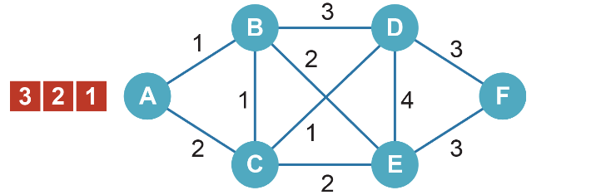

|  |  |
| --- | --- |
| 1 ms | 2 ms |
| C:\Users\Rob\AppData\Roaming\PixelMetrics\CaptureWiz\Temp\114.png | C:\Users\Rob\AppData\Roaming\PixelMetrics\CaptureWiz\Temp\77.png |
| 3 ms | 4 ms |
| C:\Users\Rob\AppData\Roaming\PixelMetrics\CaptureWiz\Temp\125.png | C:\Users\Rob\AppData\Roaming\PixelMetrics\CaptureWiz\Temp\126.png |
| 5 ms | 6 ms |
| C:\Users\Rob\AppData\Roaming\PixelMetrics\CaptureWiz\Temp\127.png | C:\Users\Rob\AppData\Roaming\PixelMetrics\CaptureWiz\Temp\128.png |
| 7 ms | 8 ms |
| C:\Users\Rob\AppData\Roaming\PixelMetrics\CaptureWiz\Temp\129.png | C:\Users\Rob\AppData\Roaming\PixelMetrics\CaptureWiz\Temp\130.png |

In which order will the packets arrive: 1, 3, 2

Justify why packet payloads are usually kept to around 1500 bytes. Consider the effects of much larger payloads on transmission time, and the effects of very small payloads on the overheads within the headers and trailers.

**Task 3**

A file is being transmitted across an Ethernet network using File Transfer Protocol (FTP)   
and TCP/IP.

Label the diagram to explain what is happening at each stage of the communication process and add arrows to show the direction of travel.

|  |  |  |
| --- | --- | --- |
| **Application Layer** |  | **Application Layer** |
| * Decides which protocol to use to transmit data, e.g if it’s a file, ftp |  | * FTP receives file requested |
| **Transport Layer** |  | **Transport Layer** |
| * Uses TCP to establish an end to end connection between source and recipient computer. * Breaks data into packets |  | * Deals with error detection; TCP reconstructs the packet in order using sequence number on each packet. * May request retransmission if it does detect errors where a packet is missing for example |
| **Internet Layer** |  | **Internet Layer** |
| * Forwards packets by selecting where the packet is sent to next * Adds IP of destination and source, finds the MAC address for the source and destination |  | * IP header removed |
| **Link Layer**   * Handles actual data transmission, transmits data to next router / device * Adds and strips MAC address and formatting. |  | **Link Layer**   * **Signals received and MAC address removed** |
|  |  |  |

Explain why TCP and IP are able to work with different application protocols and different network media, (for example HTTP web pages transferred via a fibre optic connection.)

**Task 4**

Email can be accessed on a server using two different protocols, POP3 and IMAP. Compare the differences between these.

IMAP is for keeping emails on the server like a back up, so for example if you opened an email on your phone, the email is still on server, so if you go on your computer, you can go see the email as well.

POP retrieves emails temporarily storing incoming mail, once retrieved, it is deleted, so unlike IMAP, the mail isn’t kept for very long so you cant synchronise using POP like IMAP which you can synchronise your mails between different devices.

What role does SMTP play in the delivery of email?

It is the protocol used for sending mail, simple mail transfer protocol.